Lifethroughwildlife, Jamma,



**Call for applications:**

**Fonseca Fellowships: Rejuvenating CBNRM and Wildlife Economy in Africa through Embedded Graduate Training**

Masters in Sustainable Development

Centre for Sustainability Transitions

University of Stellenbosch

**Deadline 1. Applications to Lifethroughwildlife: 31 August 2024**

**Deadline 2: For successful applicants, Academic Application to CST: 30 September 2024**

**Commencement of programme: January 2025**

**Programme background**

The Fonseca Leadership Programme provides enhanced Masters fellowships to practitioners aimed at improving conceptual and practical skills in wildlife economy and governance, with a focus on measurably uplifting communities through Community-Based Natural Resource Management (CBNRM). This programme addresses major gaps in wildlife economy and CBNRM governance, focusing on the livelihoods of the poorest people and the wildlife with which they live. These gaps have been identified by nearly one hundred trainees from ten countries and by communities themselves as the factors limiting CBNRM from achieving its long-promised potential for multi-dimensional poverty reduction.

We believe that addressing the poverty-environment crisis requires building African capacity through practical application of theory in transformational management, particularly in CBNRM anchor sites. Anchor sites are a network of emerging CBNRM sites across the region, where the devolution of wildlife benefits to households is used to institutionalise participatory governance, and to provide a direct comparison with counter-factual representational governance.

Fonseca Fellows will collaborate to rejuvenate CBNRM governance and economy in Africa. The program is based on the hypothesis that genuine participatory governance is a key missing element in CBNRM. Most fellows will work in anchor sites, where they will implement and evaluate participatory governance and compare it with conventional representational governance. Additionally, we welcome applicants focused on strengthening community or landholder associations to enhance local collective action and the wildlife economy. Fellows will typically be working professionals who can integrate their roles with the Fellowship's requirements.

**Call for applications**

We will recruit approximately eight Fellows to start in 2025, with another eight in 2026, and anticipate additional cohorts in 2027 and 2028. Our goal is to support the development of CBNRM anchor sites, so we will prioritize applications from pairs of implementers or a series of students working at these sites. We will also consider applicants focused on developing CBNRM support systems with a specific interest in CBNRM governance and economics. Our aim is to create a well-balanced and diverse cohort that can contribute to the rejuvenation of CBNRM and foster an inclusive wildlife economy in Africa.

Most successful applicants will be professionals in full time CBNRM-related employment at well-managed and potentially transformational CBNRM sites. Consideration will be given to applicants working on aspects of community governance and wildlife economy that have direct empirical application, especially if they are engaged with national associations. Applicants should ideally have completed the “wildlife economy governance and community certificate” that is part of enhanced training or should enroll in the August intake.

Fellows should be emerging scholar-practitioners with experience in CBNRM governance and economics, holding an appropriate undergraduate degree or, in some cases, relevant empirical experience. Successful candidates will demonstrate curiosity in conceptualizing their work through existing literature and the ability to translate this into practical field implementation. They will have the academic potential to measure and document their efforts in a Master’s level thesis, which may lead to scientific publications. Work will be assessed based on both field results and academic contributions. Fellows will also engage part-time in CST events and activities, focusing on understanding and managing complex social-ecological systems and research methods.

**What the fellowship entails**

The Fellowship aims to support the development of on-the-ground scholar-practitioners by enhancing their understanding of CBNRM theory and learning from field implementation, grounded in the belief that effective theory stems from practical knowledge. The Fellowship entails two core components, that are offered as a collaboration between the University of Florida in the USA and Stellenbosch University in South Africa:

1. Fellows will register for or have completed a graduate certificate in “wildlife economy, governance and CBNRM,” through University of Florida as a prerequisite for the Master’s degree. The certificate includes online full semester courses in wildlife economy (Aug-Dec) and in CBNRM governance and management (Jan-May) followed by capstone field training in wildlife economy and CBNRM, usually at B2Gold’s Otjikoto Nature Reserve in Namibia (May).
2. Fellows will complete a Master’s Degree in Sustainable Development at the Centre for Sustainability Transitions (CST), Stellenbosch University. Working students will be required to attend the following activities on campus in Stellenbosch (for which travel, accommodation and enrolment costs are covered by the Fellowship):
   1. Orientation and Foundational concepts module (~2 weeks in early-mid February Y1)
   2. Methods module (1 week in May Y1)
   3. Research dissemination module (1 week in April Y2)
   4. Research showcase event (1 week in Sept/Oct Y2)

Supervisors will include Professor Brian Child, Dr Hayley Clements, Dr Alex Chidakel and others as suitable.

Fellows will also receive empirical trainer-of-trainer skills through the Lifethroughwildlife/ Community Leaders Network micro-accreditation training system. The focus will be a set of short practical models in CBNRM governance including revenue distribution, constitutions, financial management, project management, governance compliance and monitoring of performance and compliance.

**Funding**

Fellows will typically be employed full-time. Fellowships will cover registration fees for the UF certificate and the CST Master’s program, as well as training and travel expenses for participation in campus and field events. Since this program is designed for working professionals, no living cost support is provided. Fellowships will generally align with work responsibilities and field agencies to enhance their CBNRM programs, but we also offer support for candidates without institutional backing.

Funding will cover:

1. Completion of UF graduate certificate, including two weeks of experiential training in Namibia.
2. Full costs of enrolling in the CST Master’s programme, including at least four in-person cohort events on campus
3. Training in governance micro-accreditation modules
4. A small field research grant (upon application)
5. Thesis supervision and deep mentoring

Funding will not cover:

1. Living expenses, except in exceptional circumstances, as the programme is designed for candidates that are employed in CBNRM implementation and wildlife economy.

Exceptional circumstances include applicants who are conducting valuable research directly supporting CBNRM and the wildlife economy, even if they are not fully employed. We are particularly interested in at least one candidate from the private wildlife sector who can bring cross-cultural experience to the cohort.

**Master’s research and thesis**

CBNRM governance is a critical weakness in CBNRM, but is poorly understood. This programme will engage Fonseca Fellows in a regional research programme comparing representational governance (business-as-usual) with participatory governance. Most Fonseca Fellows will use CBNRM anchor sites to test the hypothesis that face-to-face participatory governance, done properly, improves performance. Performance will be measured through social and associational capital formation, use of scarce wildlife dollars, multi-dimensional household poverty reduction, resilience to radicalization, wildlife tolerance and conservation, wildlife economy, and so on. Cohort 1 will be focused on participatory governance in anchor sites but applicants working on national governance systems and wildlife economy will be considered. Later cohorts will build on and diversify this focus.

|  |
| --- |
| **Overview of Fonseca enhanced Masters fellowship programme:**   1. Fellows will receive:    1. conceptual training through the wildlife economy, governance and community certificate (University of Florida), and    2. training on complex social-ecological systems dynamics and research methodology through the CST’s obligatory courses 2. Using this knowledge, Fellows will be trained how to conduct a situation analysis in their communities. This will include:    1. a CBNRM feasibility analysis covering the economics, governance and capacity-building interventions required at each site, and    2. training in using KoBoToolbox to conduct a livelihoods / governance / wildlife tolerance survey.   It is highly likely that Fellows will work together at one field site to do this, before undertaking this work at their own sites.   1. Combining conceptual and empirical knowledge, Fellows will be guided to develop a theory of change for the site. This will be converted into:    1. a measurable implementation plan (using a log-frame or similar format), which will also provide    2. the hypothesis and indicators for the thesis. 2. Fellows will receive training in change management and provided tools and systems for implementing resilient and participatory governance systems. This includes:    1. tools for institutionalising communities (i.e. constitutions and rights),    2. how to use revenue sharing to institutionalise change management,    3. Community management systems for rigorous financial accountability and projects management,    4. Tools and systems for tracking performance and governance compliance.   ( These tools will be developed as a micro-accreditation training stems for CBNRM managers_.   1. A Master’s thesis including a literature review, research questions, methods, data analysis, and results and conclusions from these experiments in community governance.   Fellows working on national support systems or wildlife economy, will receive the same grounded training, with mentoring in building systems to scale impacts at community level.  Timeline – see summary on next page |

Description of how the enhanced Masters combines the Certificate, the MPhil, and Practice and Impact

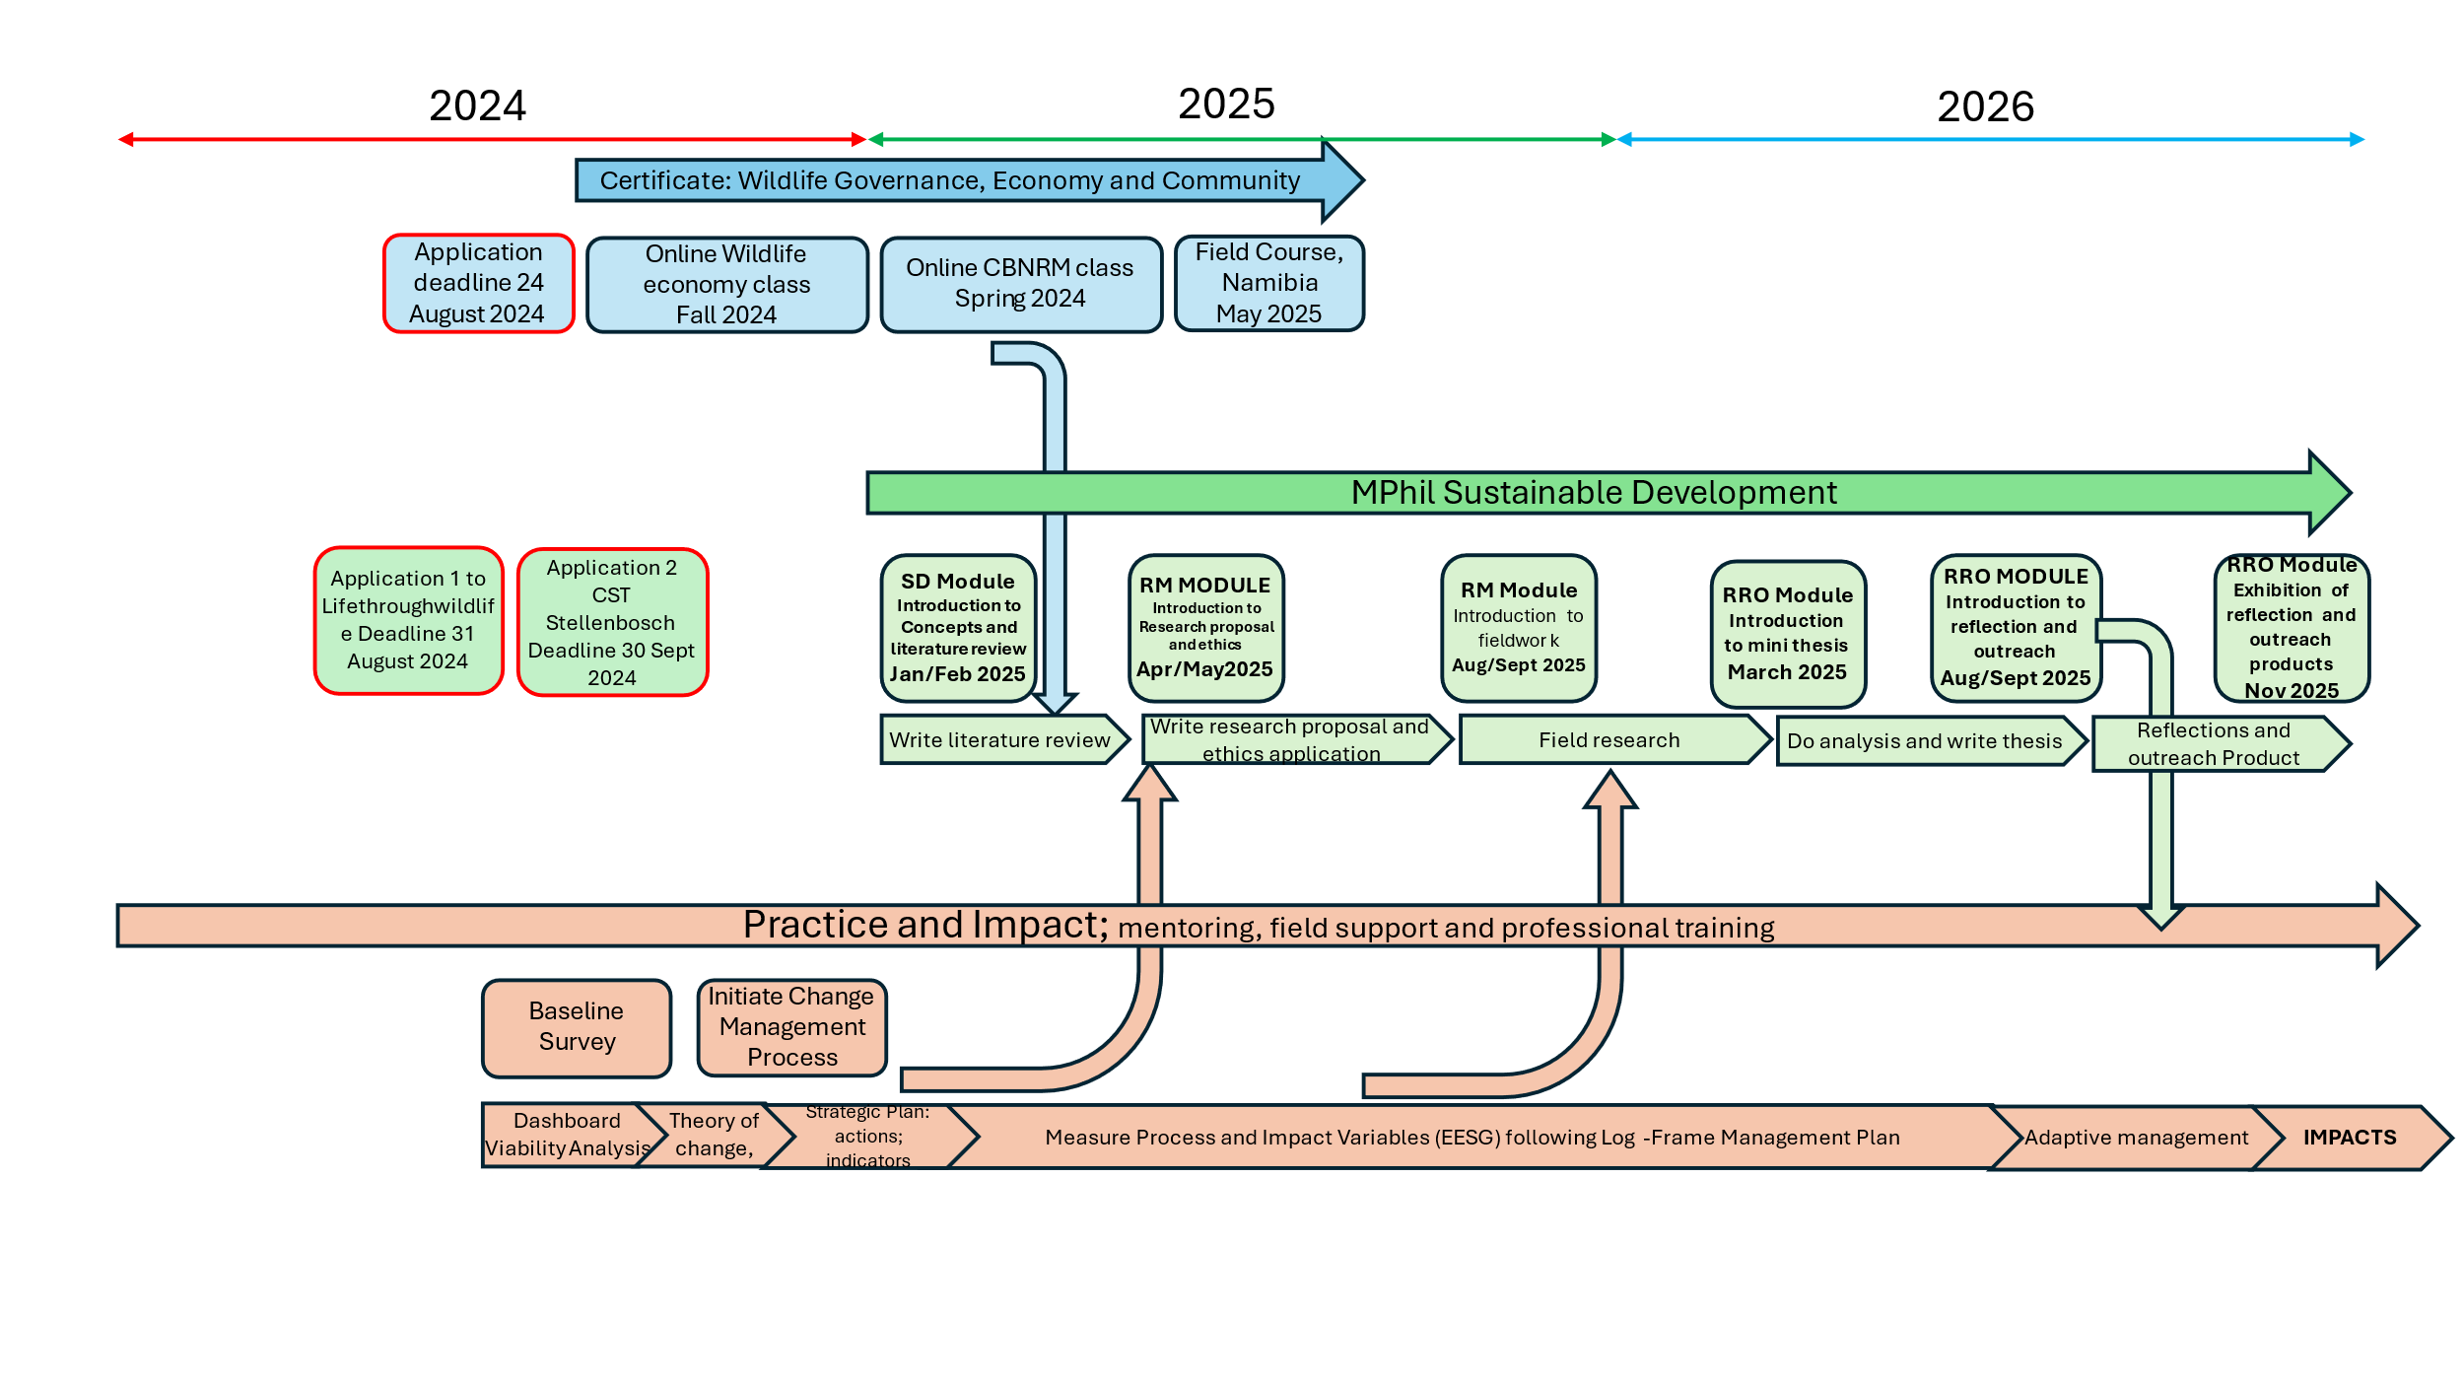

**Partners**

Professor Brian Child, Department of Geography and Center for Africa Studies at University of Florida leads the Lifethroughwildlife programme, of which this Fellowship is a part.

Dr Hayley Clements at Centre for Sustainability Transitions and the African Wildlife Economy Institute at Stellenbosch University will be the academic anchor for the programme at the CST.

The programme has been developed in partnership with the Community Leaders Network of Southern Africa. Logistics and finances will be managed by Jamma Foundation.

The Centre for Sustainability Transitions (CST, <http://www.sun.ac.za/cst>), where most of the interaction will take place, builds on a strong history of transdisciplinary research and complexity studies at Stellenbosch University, providing a vibrant research hub for solution-oriented sustainability science that hosts leading scientists and students from diverse disciplinary backgrounds in a state-of-the-art research centre. The primary objective of the CST is to provide transformational knowledge on the dynamics of multi-scale social-ecological change, and strategic insights into the new modes of research and governance that can bring about a just transition to a more equitable and sustainable society, in southern Africa and globally.

**Requirements**

Candidates should be engaged with a CBNRM or wildlife economy programme in ways that can deliver the outputs defined above. Candidates should have completed an Honours or four-year undergraduate degree or equivalent to be eligible, ideally with an average mark over 65%. Consideration can be given to prior empirical experience. Strong preference will be given to African nationals and under-represented groups.

**To apply**

This is a two-step application process.

**Step 1: Apply to the Lifethroughwildlife programme**

All interested candidates should first apply to Lifethroughwildlife by emailing [bchild@ufl.edu](mailto:bchild@ufl.edu) the following documents with the subject line “Application: **Fonseca Fellowships for Rejuvenating CBNRM in Africa**”: by **31 August 2024:**

1. Application form (appended below)
2. Curriculum Vitae (max 4 pages)
3. Academic Transcripts detailing subjects and marks for all tertiary degrees and diplomas
4. Confirmation that you have completed or enrolled in the Lifethroughwildlife ([www.lifethroughwildife.com](http://www.lifethroughwildife.com)) University of Florida certificate in wildlife economy governance and community.
5. Short letter of motivation (500 words) including:

* your previous academic and relevant work experience,
* the match between your experiences and skills and the rejuvenation of CBNRM in Africa,
* evidence of relationships with CBNRM communities, anchor sites, or community and/or landholders associations aligned with the rejuvenation of CBNRM and the wildlife economy in Africa,
* your specific interests with regard to the proposed project, and
* where you see yourself and CBNRM and the wildlife economy in ten years

1. Short concept note (800 words max) including:
   * A brief statement defining the problem (e.g. committee-based management versus participatory governance; barriers to unlocking wildlife economy activities, etc)
   * A description of the study site/s (i.e. the community)
   * Methods that you expect to use to undertake a baseline assessment of the site, facilitate change, and measure the impact/s of these changes
   * How this will improve CBNRM and the lives of rural people in Africa’s wildlife areas
2. An example of your writing (in English) e.g., a thesis, research article, etc.

**Step 2: Successful candidates will be informed how to submit their applications to the CST.** The purpose of this second step is to confirm academic eligibility at University of Stellenbosch

**Enquiries**

Enquiries can be directed to [ubchild@ufl.edu](mailto:ubchild@ufl.edu).

Please use the subject line “**Enquiry: Fonseca Fellowships for Rejuvenating CBNRM in Africa.**”

**Application Form: Fonseca Leadership Programme**

|  |  |
| --- | --- |
| Intake year |  |
| SU Student Number (if you have previously had one issued) |  |

**Applicant details**

|  |  |  |
| --- | --- | --- |
| Title | Name | Surname |
|  |  |  |

|  |  |
| --- | --- |
| Nationality | ID number / Passport Number |
|  |  |

|  |  |
| --- | --- |
| Email | Contact Phone Number |
|  |  |

|  |  |
| --- | --- |
| Home Address | Postal Address |
|  |  |

|  |  |  |
| --- | --- | --- |
| High School Completion level | School | Year obtained |
|  |  |  |

|  |  |  |
| --- | --- | --- |
| Undergraduate Degree(s) Obtained | University | Year obtained |
|  |  |  |
|  |  |  |

|  |  |  |
| --- | --- | --- |
| Postgraduate Degree(s) Obtained | University | Year Obtained |
|  |  |  |
|  |  |  |

|  |  |  |  |
| --- | --- | --- | --- |
| Empirical Experience Obtained | Job Title | Organization | Years/s |
|  |  |  |  |
|  |  |  |  |
|  |  |  |  |
|  |  |  |  |
|  |  |  |  |

|  |
| --- |
| Confirm that you have completed or are enrolled in the Certificate in “wildlife economy governance and community” and will complete this by May 2025   * Completed * Enrolled |
| Please indicate which of the below you have provided evidence for in your letter of motivation:   * are in a position to assess and support participatory governance in a CBNRM anchor site * are in a position to assess and support participatory governance that links an anchor stie to a national association * have initiated empirical research into the wildlife economy that supports community and/or landholder associations * other (noting that our focus is on participatory governance systems, we will consider exceptional proposals aligned with strengthening community governance and economy). |
| Do you work with or for a CBNRM organization and community?   * Yes * No |
| Describe the organization and your role |
| Can you integrate your thesis (i.e. governance research) into your employment or work responsibilities?   * Yes   No  Briefly explain how: |
| Will your organization support you over the next two years to do so? State how and provide evidence. |

Please check that the following are included in your application

|  |  |  |
| --- | --- | --- |
|  | Application form | Complete all sections of this form |
|  | Curriculum Vitae (max 4 pages) | List previous education, training, degrees, work or research experience |
|  | Short letter of motivation | Provide a brief description of your ambitious for pursuing the Fonseca Fellowship and MPhil, how this links with your current context of work / study / personal goals, and what impacts you hope to make in the next ten years |
|  | Short concept note | Provide a brief outline (1-2 A4 pages) max 800 words of your proposed research for your MPhil |
|  | Academic Transcripts | For all previous tertiary degrees, detailing all subjects and marks |
|  | Example of your writing | A research paper, report, thesis or thesis chapter, etc |