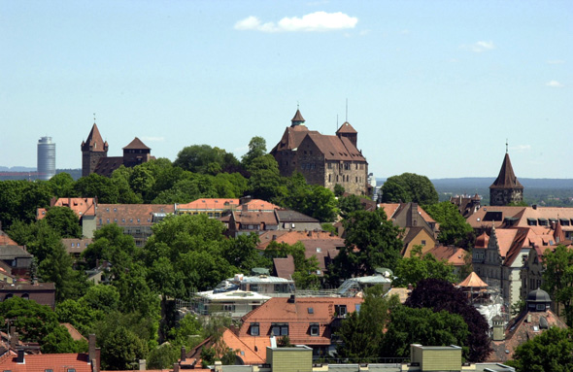

# Hotel Prinzregent (within walking distance of the campus) <http://www.prinzregent.net/en/>

# Hotel Klughardt (easy access with tram no.8 or subway U2) <http://www.hotel-klughardt.de/>

# Hotel St.Peter (easy access by city bus no.36 and good parking opportunities) <http://www.hotel-st-peter.de/homepage-englisch.html>

Recommendations

Technische Hochschule Nürnberg Georg Simon Ohm

Housing options in Nuremberg

Please be aware that Nuremberg is an event city and to ensure that there are still availabilities, hotel bookings need to be done in good time before your intended arrival.

The International Office can assist you with advice, but making the hotel reservation is your own responsibility.

* When booking the rooms, let the hotel know that you are with the Technische Hochschule Nürnberg and in most cases, you are eligible for a discounted rate.
* A sum of 100 Euro per teaching day is allocated for accommodation in lieu of the “OHM lectureship program”. The lump sum for the entire stay will be paid to your account and you are responsible for paying the hotel directly.

An additional accommodation option is:

* Staying in one of the guest rooms in the TH Nürnberg owned apartments. All rooms are in apartments with cooking possibilities and shared bathrooms within close proximity of the lecture buildings on campus.   
  If this is an option for you, please advise us when preparing your trip, as we have to check availability.   
  Also, a moderate amount is charged for these rooms, hence we would have to adjust the accommodation remuneration accordingly.

Of course, you are more than welcome to book other accommodation options according to your preferences, such as Airbnb for example.