SOTL 2017: SUMMARY
This year the Division for Learning and Teaching Enhancement hosted the 10th annual Scholarship of Teaching and Learning conference at the Lord Charles Hotel in Somerset West. Starting out with about 50 participants in 2007, this conference has grown to such an extent over the past ten years that we have seen a bumper edition of approximately 250 SU colleagues attending this year’s event, hosted from 23 to 25 October 2017 at the Lord Charles Hotel in Somerset West. The conference programme took a particular focus on the history and development of the scholarship of teaching and learning at SU over the past decades, as well as taking a forward look to the next ten years.

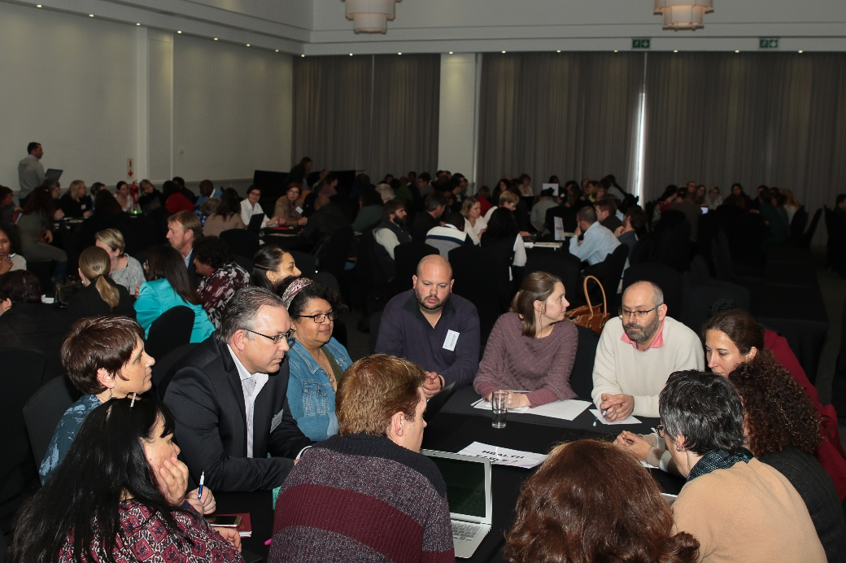

The seven pre-conference workshops held on Monday, 23 October 2017, were attended by a number of colleagues and were found extremely valuable by those who participated. This is confirmed by feedback such as:
“That one can classify how to teach at different levels in an uncomplicated, yet highly useful way.”
“The times dedicated to actual writing/constructing ideas. Comprehensive knowledge presented (full framework).”
“The activities kept us all engaged and interested.”

It has to be noted, however, that 25 colleagues who formally registered for particular workshops, failed to attend. Although workshop facilitators sent e-mails to their workshop registrants to confirm their participation, most of the absentees neglected to inform the facilitators or the conference organisers that they will not be attending. This has not just caused the workshop facilitators to prepare for participants in excess of the numbers that were eventually present, but also implied unnecessary expenditure of R11 250 in terms of catering. With our University being subject to a very challenging economic climate, it is sad to have to report on such a matter.
On a more positive note, the two full conference days (on 24 and 25 October 2017) were very well attended. On 24 October 2017 we had 215 delegates attending, while on 25 October the number of delegates rose to 235. Delegates were officially welcomed by a pre-recorded video-message by prof Arnold Schoonwinkel (Vice Rector: Learning and Teaching) who emphasised innovative teaching practices, the professionalisation of the teaching role and the recognition and reward of good teaching as important aspects within SU’s institutional vision and mission.
All 10 faculties were represented as well as various Centres and Divisions, the Library and special guests. As a guest of the Language Centre, Prof. Rebecca Babcock (University of Texas of the Permian Basin, United States of America) attended some of the pre-conference workshops as well as the two full conference days. Dr Babcock mentioned that our conference was an excellent example of team work and institutional recognition of the scholarship of T&L, something which she described as missing at her own institution. Dr Esmarié Strydom (Director: CTL at North West University) and Dr Annelize Cronjé (Teaching Advisor: CTL, North West University) also attended the two full conference days as a benchmarking exercise, since their institution also hosts annual SoTL conferences.
This year’s conference also saw the inclusion of three keynote presentations, instead of the usual two. Dr Antoinette van der Merwe, Senior Director of the Division for Learning and Teaching Enhancement, addressed the audience on the topic of “Celebrating 10 years of learning and teaching at Stellenbosch University: An ongoing journey”. She took a broad institutional view of the past 10 years by focusing on structural changes which contributed to an enabling environment for the professionalisation of the teaching and learning role of academics, as well as the growth in innovative practice, scholarly teaching and the scholarship of learning and teaching as evidenced in the presentations at the SoTL conference, publications in Learning and Teaching and Fund for Innovation in Learning and Teaching (FIRLT) applications.
Prof Brenda Leibowitz from the University of Johannesburg shared a broader view with her presentation on “ SOTL in the global South: Implications for university teachers researching their practice”. She discussed the ethical obligations for academics who wish to research their own practice and to publish on this, as well as the avenues that exist and that are being created for SOTL in the global South. The third keynote was presented by Prof Francois Cilliers from UCT, who spoke on “Looking back to look forward: 10 years of enabling SoTL at SU”. He reflected on the SoTL conference as an initiative that contributes to creating an enabling environment for SoTL, and the FIRLT grant scheme as an initiative creating a community of practice. The keynote presentations were special in the sense that all three keynote speakers were founding members of the annual SOTL conference at SU.
The conference programme included an impressive array of topics, such as transforming the curriculum, social justice in teaching and learning, technology in education, assessment and feedback, academic literacies and reflection. In total, we had 75 presentations (73 papers, 1 interactive discussion, 1 panel discussion). The poster session inluded an unprecedented number of 23 posters in total, of which 4 were SOTL posters. For the first time in the history of the conference, 19 PREDAC posters were showcased as part of 2017’s induction programme for newly appointed lecturers’ at SU! This was an opportunity greatly appreciated by the PREDAC 2017 participants, and was described by one as:
“a safe space for new lecturers at SU to learn the rules of engagement for academia. This conference, together with the PREDAC programme provides a good platform for new lecturers.”
The feedback from delegates once again indicated the opportunities which this conference provides for networking with colleagues across the university as one of its major benefits. Other positive feedback included:
“Being able to ask questions and making comments at the end of the presentations.”
“Hoor wat ander mense doen, praat met ander oor onderrig. Kry erkenning of minstens blootstelling vir die moeite wat ‘n mens doen.”
“Varied types of presentations.”
“Om op hoogte te bly van wat in die praktyk gebeur.”
“Sharing of ideas; providing inspiration for own teaching practice.”
“Finding new ideas to influence my own/faculty’s teaching approach.”
Regarding how the conference could be improved in terms of organisation and format, delegates made suggestions such as:
- Pre-conference workshops spread over two days as the topics are quite vital;
- Create dialogical spaces and audio-visual presentations such as video presentations;
- Attention to better representation from all faculties and variance in types of presentation in terms of disciplines;
- More focus on academic support initiatives;
- Question time at the end of sessions can be increased;
- More space for reflection or discussion about the collection of presentations in particular time slots, pulling through the golden thread. This could be led by the chair of the session;
- Providing an option to sign up for half day (i.e sessions before / after lunch – and to opt in for lunch or not) – some people couldn’t take off 2 whole days;
- Bring in the voice of students – both undergraduate and postgraduate.

Six papers were nominated as potential winners for best conference presentation. This judging process was adjudicated by a panel of three judges, of whom two were external to SU. Although papers were submitted according to 2 streams (research-based and practice-based), the review committee eventually decided that all potential winner papers would be judged on the basis of showing a particularly strong research base. Especially the overall winner had to show strong evidence of this. The six contenders included:

- Michilene Meyer Adams & Wilmarie Grobbelaar (Faculty of Economic and Management Sciences): “facilitating transformation in education: A multi-dimensional approach”
- Bjorn von der Heyden (Faculty of Science): “Near-peer and video learning to enhance student engagement with geological knowledge”
- Bjorn von der Heyden (Faculty of Science): “Outsourcing to the experts: Industry interviews as a tool to advance knowledge of the applied aspects of Economic Geology”
- Marianne McKay (Faculty of AgriSciences): “ ‘Inhabiting a more ambiguous self’: Using discomfort to explore issues of social justice”
- Alwyn Louw (Faculty of Medicine and Health Sciences): “Generic skills in the Inter-Professional Phase of the curriculum: How do students experience it?”
- Loumarie Kistner (Division for Institutional Research and Planning): “Addressing the need for student data for research - introduction to SUN-i business intelligence system”

With her paper entitled “‘Inhabiting a more ambiguous self’: Using discomfort to explore issues of social justice” Marianne McKay from the Faculty of AgriSciences walked away as the overall winner. This has won her one free attendance towards an international Teaching and Learning conference of her choice in 2018. Bjorn von der Heyden from the Faculty of Science won 2nd prize for his presentation entitled “Outsourcing to the experts: Industry interviews as a tool to advance knowledge of the applied aspects of Economic Geology”. This has won him free attendance to Heltasa 2018 or any other disciplinary educational conference of his preference. For the second year in a row, Marianne McKay from the Faculty of AgriSciences, won the delegates’ choice prize which grants her free attendance to Heltasa 2018 or any other disciplinary educational conference of her preference. Marianne deserves special recognition as she has made history by winning both the adjudicated process as well as the delegates’ choice.

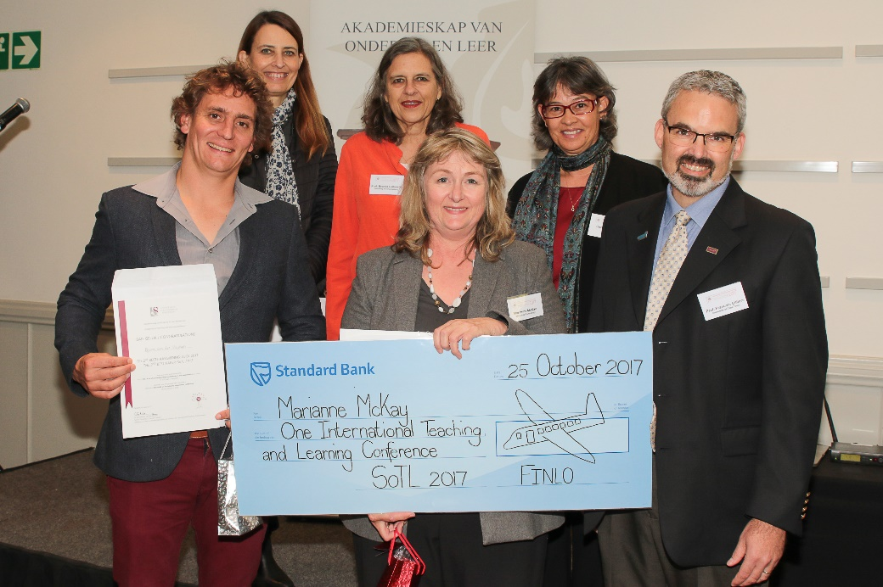

The closing session, which focused on the topic “Imagining a future for Learning and Teaching @ SU: The next ten years” evoked rich discussions amongst conference participants in the form of faculty buzz groups. The discussions were captured by scribes and will be sent to the faculties for their follow-up.

