Gibbs Reflective Cycle Template

Gibbs, G. (1988). Learning by doing: A guide to teaching and learning methods. London: Further Education Unit

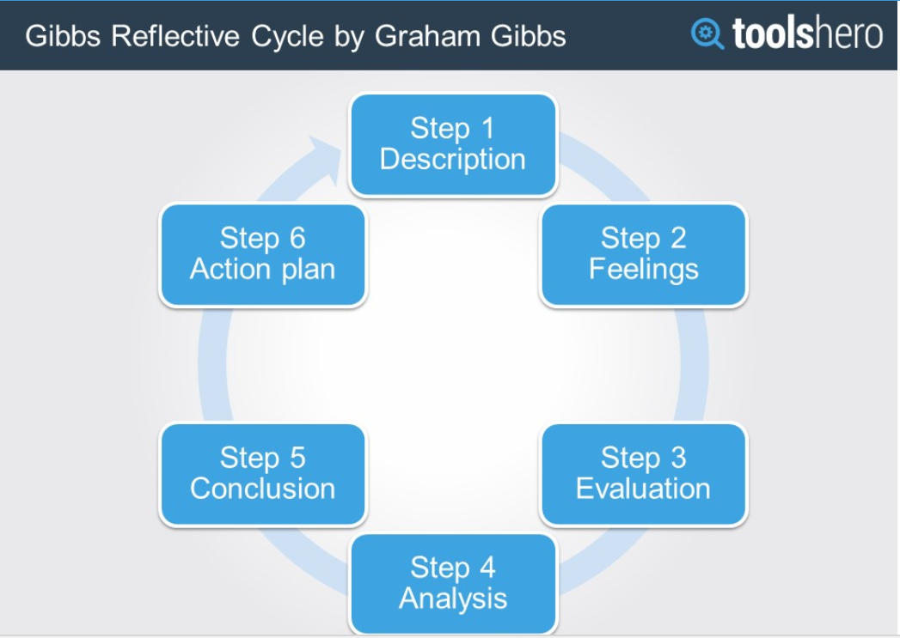

Use the Gibbs Reflective Cycle template (see next page) as a basis for systematic reflection on personal actions. Answer the sample questions within the different steps to go through an entire cycle. The fields are editable. You can also clear the field and print this template to create hand-outs.
For more information on this method and the different steps, visit:
https://www.toolshero.com/management/gibbs-reflective-cycle-graham-gibbs/
Gibbs Reflective Cycle Template

Step 1: Description
What happened?
When did it happen?
Where did it happen?
Who were involved?
What did you do yourself?
What did other people do?
What was the result of these actions?

Step 2: Feelings
What did you feel leading up to the event?
What did you feel during the event?
What did you feel after the event?
How do you look back on the situation?
What do you think other people felt during event?
How do you think others feel about the event now?

Step 3: Evaluation
What went well during the event or activity?
Why was that? What didn’t go so well?
Why was that? What was your contribution?
What contribution did other people make?

Step 4: Analysis
What have you learned from the situation, event or activity?

Step 5: Conclusion
To what positive experience did the event, situation or activity lead?
To what negative experience did the event, situation or activity lead?
What will you do differently if the event, situation or activity were to happen again in the future?
Which skills do you need to develop yourself in a similar event, situation or activity?

Step 6: Action plan
In this final step it is your turn to develop actions for future situations based on the conclusions of step 5.

