Mezirow's Transformative Learning Theory (1990):

Mezirow presented three types of reflection and their roles in transforming meaning schemes and perspectives: content reflection (description= what) in which you think deeply about the content of what was taught/learned or of the problem; leading to process reflection (=how) in which you consider and evaluate the strategies/methods used to teach/facilitate learning or to solve the problem; leading to premise reflection in which you confront (question= why) your personal assumptions and values / the merit and relevance of the problem.

Content reflection involves thinking back to what was done and, therefore, might involve a transformation of a meaning scheme (see Figure 2). For example, a teacher might ask, “What do I believe I can do with PowerPoint in my Grade 6 class, given my knowledge and past experiences?”

Process reflection causes a person to consider the aetiology of actions and whether there are other factors yet to be unveiled; this form of reflection might also transform meaning schemes (see Figure 2). For instance, a teacher might ask, “What were the positive and negative factors when students created PowerPoint projects that will assist me in planning the lessons for this new program?”

Premise reflection requires the person to see the larger view of what is operating within his or her value system, for instance, and could transform a meaning perspective rather than a meaning scheme (see Figure 2). For example, the teacher might ask, “Why is using PowerPoint so important to me at this time in my career when I could use the same strategies I have used for 20 years?” Thus, critical reflection is the process of premise reflecting (see Figure 2).

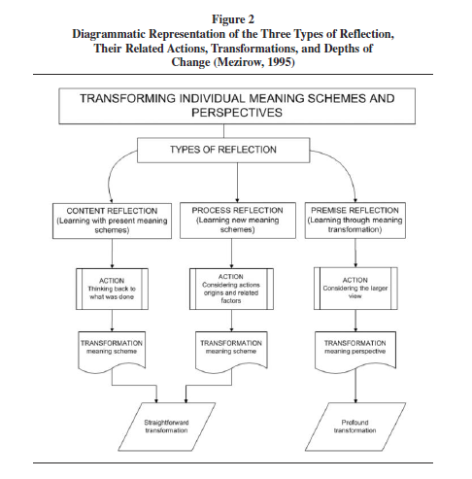

Andrew Kitchenham 2008. The Evolution of John Mezirow's Transformative Learning Theory.
Journal of Transformative Education 2008; 6; 104. DOI: 10.1177/1541344608322678

