Schön (1983, 1987, 1991): The reflective Practitioner
Donald Schön’s concepts of reflection-in-action (thinking on your feet while acting, e.g. people having a good conversation, people playing jazz – requires spontaneity, is unpredictable) and reflection-on-action (thinking about what we did afterwards, looking at our assumptions, recalling what we were thinking, feeling and doing, to understand the roles of the teacher and the student better).
To these two concepts Reid (2004) added reflection-for-action, i.e., planning forward on the basis of the reflection one has already done.

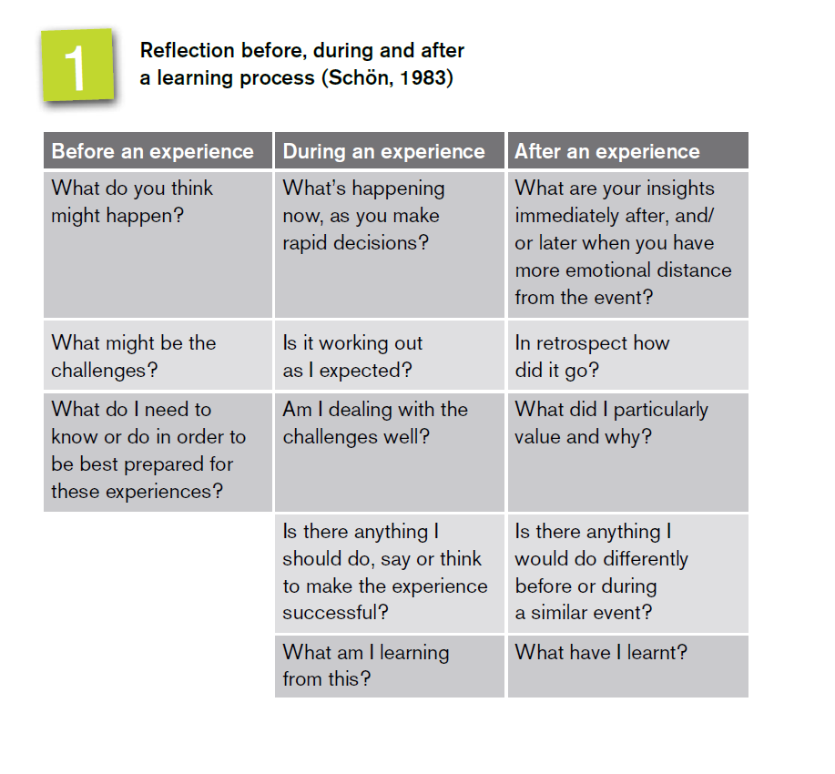

Schon, D. (1983) The Reflective Practitioner: How Professionals Think in Action. New York: Basic Books.
Schon, D. (1987) Educating the Reflective Practitioner. San Francisco: Jossey Bass.
Schon, D. (1991) The Reflective Practitioner: How Professionals Think and Act. Oxford: Avebury.

